Getting to NCACI

NOTE: The Center has single-use parking fee waivers for our off-campus guests that are valid in any OSU pay garage. (That means any OSU garage that you get a time-stamped ticket when entering.) The closest OSU pay garage is the Tuttle Park Place garage (see the orange circle in Figure 1 & Figure 2). Fisher Hall is denoted by the blue circle in Figure 1 & Figure 2. (See Figure 4 for an area map.)

To get custom driving directions to the Center or OSU parking garages, we suggest you use services such as MapQuest, Yahoo Local, etc. (There are links below for directions to the Tuttle garage.)

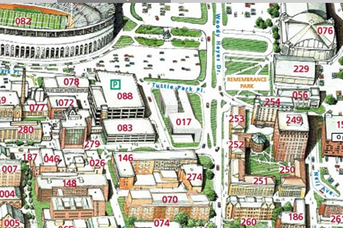
Figure 1

Link to OSU map: http://www.osu.edu/map/building.php?building=249

The address of the Tuttle Park place garage is:
Parking Garage: Tuttle Park Place
Building 088
2050 Tuttle Park Pl
Columbus, OH 43210

Link to Yahoo Local driving directions to Tuttle garage.

Link to MapQuest driving directions to Tuttle garage.

The address to Fisher Hall is:
NCACI, Fisher Hall
301 Fisher Hall
2100 Neil Ave
Columbus, OH 43210

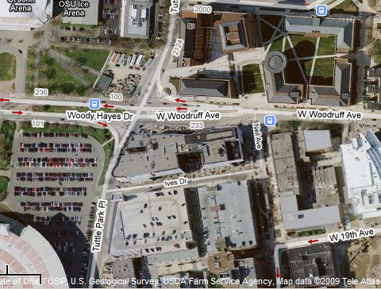
Figure 2

Once parked at the Tuttle garage, it is suggested to take the elevator (denoted by the red circle in Figure 2) and follow a walking path denoted by the yellow arrows in Figure 2. An entrance to Fisher Hall can be seen in the orange circle in Figure 3. Once in the building, the elevators should be directly ahead.

To NCACI offices

Go to the 3rd floor. When getting off of the elevator, look for round, wooden columns. Turn away from them, to your right you should see a banner for NCACI. Walk down the right hand hallway to the end of the hall, make a left and our offices are straight ahead (room 301).

To Fisher 500 conference room

Go to the 5th floor. When getting off the elevator, look for wood and glass doors. That is room 500.

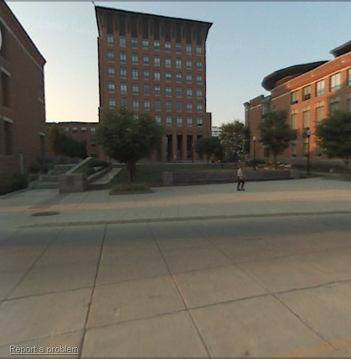
Figure 3
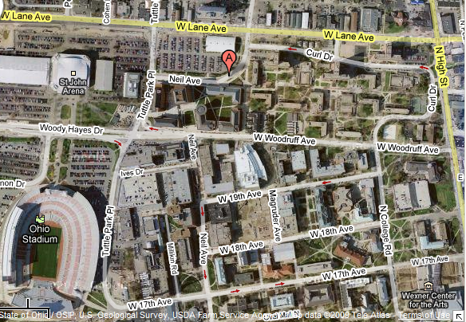
Figure 4

In Figure 4 the orange circle is the Tuttle parking garage and the blue circle is the Fisher Hall.

